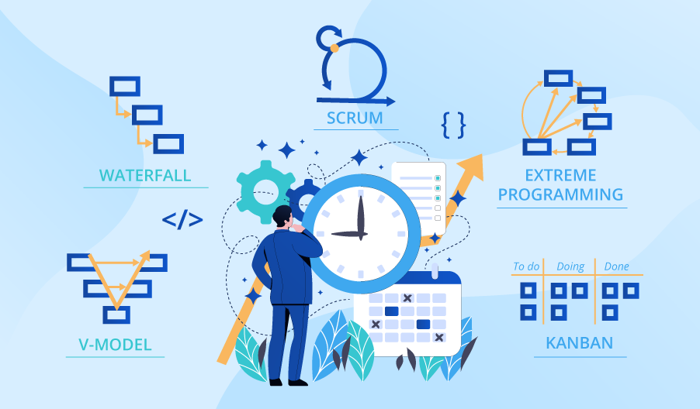

**SE423**

**Software Project Management**

**Project**

**Incremental Artifact-Based Project Planning**

Your team will create a series of artifacts based on one of the following scenarios:

* Scenario 1: CRM Rewrite
* Scenario 2: Remote Sensing Management & Tracking
* Scenario 3: State Metro System
* Scenario 4: Human Reconnection & Identification System
* Scenario 5: Water Monitoring & Alert System
* Scenario 6: Athletic Health Compliance & Monitoring System

Note that each artifact should include previous artifacts (in the same document), which should be improved based on instructor and peer feedback as well as changes that are prompted by work on later artifacts. Removed content should be strikethrough (Google docs: format menu) and changed/added content should be highlighted in yellow.

See course website and LMS for due dates. Some meeting time will be provided in class, but quality artifacts will require groups to meet independently as well. See the Course Website for grading criteria/rubrics.

Note that the format of each artifact is up to you (paragraph, bullets, charts, externally referenced files, etc.), but that the reader should gain a clear understanding of the project and the circumstances surrounding it.

**Artifact 1: Overview, Organizational Structure, and Scope (20% of Project Grade)**

As a newly formed team, it is important to define why your team has been formed as well as what their goals are. Relying heavily on the project scenario, construct an overview of the project (similar to a charter), which should include:

* A clear **problem/opportunity statement**
* The **goals and/or projected benefits** of the project
* An initial **stakeholder list**. Note that this does not require a great deal of detail.
* The **team and relevant organizational structure**. Note that you may use a team structure of your choosing (your team, a contracted team, existing resources within the organization, a mixture of these, etc.), but be sure to include information relevant to the success of the project.
* A **detailed scope statement** containing all features your team will provide. Be sure to avoid redundancies within this section.

**Artifact 2: Methodology Analysis, Risks, and Decision (20% of Project Grade)**

Now that your team has committed to your given scope for the project, you will need to decide on a process methodology. This may be a Plan-Driven or Agile methodology, but it must be an informed decision. **Analyze 4 methodologies**, including 2 Plan-Driven and 2 Agile, to determine which is the best fit for your project and organization structure. Consider the characteristics of each methodology with your selected project in mind:

* What are the strengths and weaknesses of the methodology in the context of this project's goals and scope defined in the last artifact?
* How would this methodology mesh with the team/organizational structure and stakeholders you defined in the last artifact?
* Create a mini **risk registers** with 4 risks specific to the explored methodology. This register need only have three columns: Risk name, Description of Risk, and a single Mitigation. These risks should be potential problems that are unique only to this methodology, not the other 3 you analyze.

After completing your analysis, **select a methodology** (from the 4 analyzed) which your project would intend to use. For this methodology:

* Discuss why it was selected over the others; be sure to further explore the context established in your previous artifact.
* Expand the risk register to include both additional columns (Probability, Impact, Risk Exposure, First Indicator, and additional Mitigation/Management Strategies) and four more risks not directly related to the methodology (other internal or external risks).

Note that your selected methodology will affect artifacts later in the semester. Additionally, a portion of the grading of this artifact will include a review of changes to the previous artifact.

**Artifact 3: Estimation and Scheduling (20% of Project Grade)**

With a process methodology selected and a defined scope, you will now estimate the amount of work existent in your project and produce a schedule.

To estimate, you will create a bullet-list **Work-Breakdown Structure** (WBS). This will contain all activities or components necessary to complete the project in your agreed-upon scope. It is your choice whether to use a process, product, or hybrid WBS, but consistency is expected throughout the entire structure.

To **schedule**, you will produce requires different artifacts based on whether your team selected a Plan-Driven or Agile methodology. If you have selected:

* Plan-Driven:
  + Using a method covered in class (top-down, bottom-up, CoCoMo, etc.), estimate **how long each element** of the project will take. Estimates will need justification and should clearly demonstrate **the process you used** to arrive at your numbers.
  + Produce a **Gantt chart** derived from your work breakdown structure and your estimates. This should include the estimated measure of time for each task, dependencies, and sequencing (critical path, resource assignment, etc.).
  + Parts of this may be delivered as a Microsoft Project file, but a companion document with justifications, rationale, etc. will also be needed.
* Agile:
  + Produce a full **product backlog** of basic User Stories (with correct form) that capture the features that will be delivered by your team. Though these stories need not be fully elaborated, you will need to estimate story points (effort) for each user story.
  + Create a basic overview of the **technical process** your team will follow. This will include timing, meetings to be conducted, and additional elements such as Sprint 0, spikes, epics, etc.
  + Finally, create a **Sprint 1 backlog**, fully elaborating each story (acceptance criteria, additional details, etc.)

Note that a portion of the grading of this artifact will include review of changes to previous artifacts, especially the one immediately preceding it.

**Artifact 4: Stakeholder Analysis, Communications Plan, and Metrics (20% of Project Grade)**

To ensure your communication is effective, you will codify a complete communications plan. The first step is determining and analyzing who needs to be informed about the project. Expanding on the initial list created in Artifact 1, create a basic **Stakeholder Register** which includes the following elements:

* Stakeholder individual/group name, title, etc.
* Classification (scheme up to your team)
* Level of power/ ability to affect the project 1-5 (use a Likert scale if preferred)
* How the stakeholder can affect the project
* Level of interest/ ability to be affected by the project 1-5 (use a Likert scale if preferred)
* Artifacts/metrics to communicate with stakeholder (must be completed in compliance with the metrics artifact below)
* Basic stakeholder management strategy to use throughout the project

Once the Stakeholder Register/Analysis is complete, construct a basic **Communications Plan**. There should be an entry in this plan for each category of information that must be conveyed (such as status, risks, and changes [to scope or other]). Each entry should include:

* Why the information is meaningful and must be conveyed
* Who it should be shared with
* How it should be conveyed such as the format (email, in-person, etc.) and tone (impersonal, formal, etc.)
* Who will be responsible within your organizational structure for the communication
* When and how frequently this communication will be made

The communication plan can be formatted however you choose, but the answer to each question above should be apparent to the reader. Be sure to include the metrics-related communications outlined in other sections of this artifact.

**Metrics** are needed to assess your work as well as effectively communicate status to stakeholders. Given the circumstances of your project, the stakeholders you have analyzed, and the planned communications, devise at least four relevant metrics to be collected. For each, be sure to explain the following:

* Why the metric was chosen; the rationale
* What measurements are to be taken, how often, by whom, etc. to create the metrics
* How it is to be used, and how it will benefit the project, team, stakeholders, etc. as time progresses

Note that a portion of the grading of this artifact will include review of changes to previous artifacts, especially the one immediately preceding it. Additionally, a portion of this grade will focus on the cohesiveness and quality of all of the artifacts (4 total) when considered as a single body of work.

**Final Presentation (20% of Project Grade)**

10-minute presentation. The team is expected to cover the breadth of the 4 artifacts in a way that interests and educates the audience.

Note that simply following the artifacts in order is probably not going to produce the best result - rather think about what and what order is appropriate for the presentation length as well as the audience (your classmates) and the scenario you are presenting.